Final Project

Part 1:

**Answer 1:** The list of keywords that I have chosen are as follows:

* Flat Web
* Bootstrap web
* Web design
* Website creator
* Responsive Web design
* Build a website
* Website creator

**Reason:** I have picked these Keywords to improve my site positioning while at the same time looking in google. These catchphrases are exceptional and of fitting length neither too short nor excessively long and effectively to discover. In this aggressive world, these watchwords will help in expanding the hunt pace of my site.

**Answer 2:**

<?xml version="1.0" encoding="UTF-8"?>

<urlset

xmlns="http://www.sitemaps.org/schemas/sitemap/0.9"

xmlns:xsi="http://www.w3.org/2001/XMLSchema-instance"

xsi:schemaLocation="http://www.sitemaps.org/schemas/sitemap/0.9

http://www.sitemaps.org/schemas/sitemap/0.9/sitemap.xsd">

<!-- created with Free Online Sitemap Generator www.xml-sitemaps.com -->

<url>

<loc>http://13.92.37.73:8059/Jajwant Singh/</loc>

<lastmod>2019-12-11T19:03:23+00:00</lastmod>

<priority>1.00</priority>

</url>

<url>

<loc>http://13.92.37.73:8059/Jajwant Singh/index.html</loc>

<lastmod>2019-12-11T19:03:23+00:00</lastmod>

<priority>0.80</priority>

</url>

<url>

<loc>http://13.92.37.73:8059/Jajwant Singh/about.html</loc>

<lastmod>2019-12-11T18:59:41+00:00</lastmod>

<priority>0.80</priority>

</url>

<url>

<loc>http://13.92.37.73:8059/Jajwant Singh/work.html</loc>

<lastmod>2019-12-11T19:00:58+00:00</lastmod>

<priority>0.80</priority>

</url>

<url>

<loc>http://13.92.37.73:8059/Jajwant Singh/contact.html</loc>

<lastmod>2019-12-11T19:02:09+00:00</lastmod>

<priority>0.80</priority>

</url>

<url>

<loc>http://13.92.37.73:8059/Jajwant Singh/single.html</loc>

<lastmod>2019-12-11T18:45:09+00:00</lastmod>

<priority>0.80</priority>

</url>

</urlset>

**Answer 3:** Local competitors:

* Autopark.com
* Beertown.com

**Answer 4:**

**Backlinks for Autopark.com**

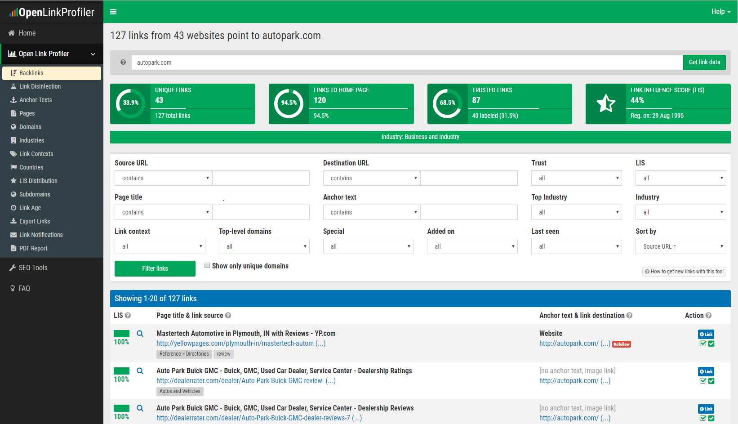

**Backlinks for Beertown.com**

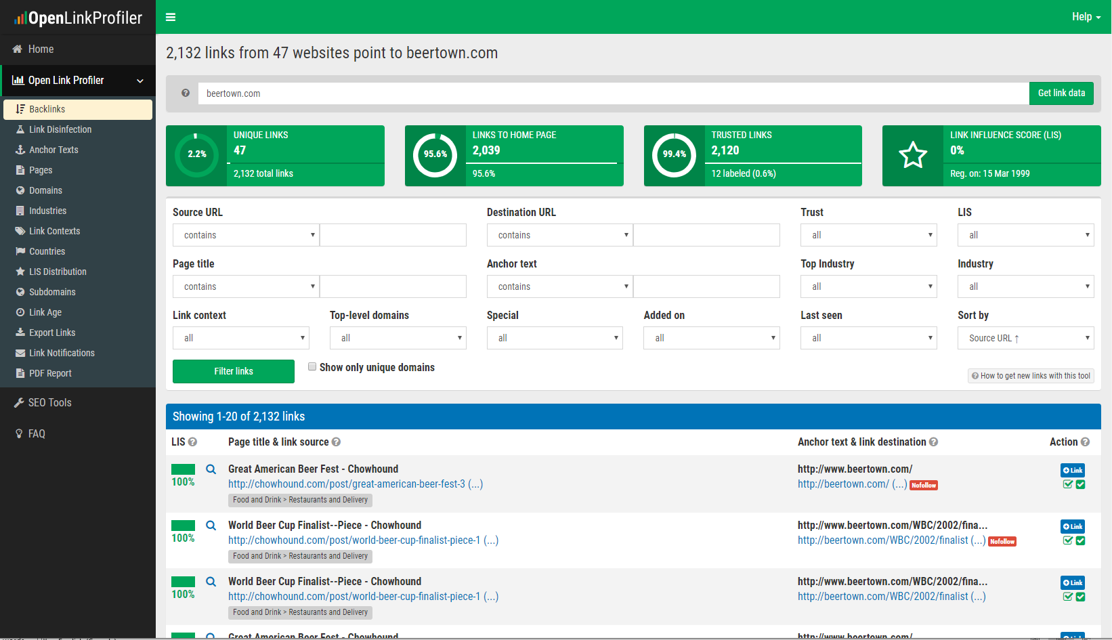

**Answer 5:**

1. **Format your page**: You can improve your number of positioning of SEO technique when you will be concocting the design of your site. It ought to be clear and sorted out. For example, your text dimension, textual style and typography. Also, you should utilize most of the hued content, intense text styles. Include more than content: It is most significant thing which will exceptionally supportive for us to build our check of positioning, that your substance on your site ought to be just in composed words. If you will give the clear majority of the data including pictures, recordings, slide shows or sounds then guests will want to visit on site.
2. **Content**: You can rise your positioning measure of your site when you have applicable substance. It Should be forward-thinking after some time. Also, consistently want to utilize intense, italic, heading labels, for example, (Specially a h1), and other significance labels to feature these catchphrases Phrase. Besides, your content ought to be appropriate and clear for client.
3. **Improve Images**: Pack and Resize the pictures will assist us with improving the positioning. We can straightforwardly utilize the item name instead of naming the picture. Just as we can likewise use the inscriptions and depictions with respect to the items; which will assist us with making our position on the top.
4. **Create the Blog:** It is a smart thought to container a blog; when you will have a colossal measure of perusers and adherents. Through the sites they can peruse their preferred significant substance. Just as we can put watchwords which can pull in more perusers and adherent to our site.
5. **Multiple Keywords Phrase**: The catchphrases are most significant piece of your site. It must be pertinent with your business and another pages.
6. **Remove the errors on link:** We should ensure that we give the connection with no mistakes. Since it diminishes the site watchers and SEO Rank when the site see isn't happy with the administrations regarding the connection. At whatever point any of the client utilize any connection from our site they ought to need to bring to the bona fide page instead of some invalid site.
7. **Promote the website on social media:** We can improve the SEO positioning by means of sharing the site interface with our adherent through the web-based life and social locales, for example, Facebook, WhatsApp, twitter and LinkedIn. At whatever point we share the site interface via web-based networking media there are the most extreme potential outcomes to build the SEO Ranking because of the alluring connection title via web-based networking media. Be that as it may, watchers can locate some fascinating connection by means of web-based life. These days internet-based life is an extraordinary method to improve and build the SEO positioning.